The Genesis Calendar of Prophecy
‘Holy Days a Prophetic Outline’
A brief description
hyh hyh
The Genesis Calendar Maintains the days and nights, weeks, months, years, weeks of years with 7 years completing a week. The Yobel (Jubile) and most importantly Shabbath’s, Seasons (Tekufah) and Holy days.
The Days then Nights are represented according to Genesis chapter One and are shaded
for reference, the days with zero’s are seasonal days, a total of four being 2 Equinox and 2 solstices the zero time being the transitions from one season to the other.
Days then nights are shown with some the following example verses:
(Gen 7:4,12 Exo 24:18 34:28 De 9:9,11,18,25 10:10 1sam 30:12 1ki 19:8 Job 2:13 Jonah 1:17 John 9:4-5)
The weeks are defined from the beginning in Genesis -- 7 days were created which began
the week ending with the shabbath day. (Gen 1:31 Gen 2:1-3)
The months are named by their Hebrew numbers as according to the following verses. (Gen 7:11 Gen 8:5 Lev 23:5)
The years over the centuries are as close to being accurate as possible taken into account of the variance throughout history, staying within the bounds of scripture, and being as correct as possible with no more than a plus or minus of 3 years. (Gen 1:14)
The week of years, The Yobel once every 50th year after 7 weeks of years with a 7-year
cycle and with completion of the 7th year Shabbath’s for each week. (Lev 25:1-13)
The Shabbath defined as the seventh day of creation. (Gen 2:1-3)
The Seasons are presented by the Hebrew term, Tekufah, those four days represent the
four Seasons of the equinox and solstice. The Spring Tekufah (Spring Equinox), sets the start of
the calendar month of 30 days for a duration of 12 months (360 days), plus the 4 Tekufah days
each being added between seasons to a solar year, brings the total number of days per year to
364.

Thus, the Genesis Calendar being self-corrective with one day for each week of years totaling
7 days at the end of 49 years, going into the Yobel (Jubile), putting the calendar back in line
with 365 days of a solar year. (Gen 1:14 Lev 25:1-4)
The Holy days which define prophecy and a plan. The Holy days land on certain days and
the calendar must show that. Passover should be on 14th day the middle of the week (Lev 23:5),
Feast of Unleavened bread starts on the 15th day (Lev 23:6), The Wave sheaf the day after the
Shabbath (Lev 23:5), then to Pentecost (Feast of Weeks) on the 50th day, always on the first day
of the week (Lev 23:15-22), Feast of trumpets on the first day of the 7th month (Lev 23:24-25),Day of Atonement on the 10th day always on a sabbath but starting the night before (Lev 23:27-32), Feast of tabernacles starting on the 15th and ending 8 days later (Lev 23:39).
The layout of the Genesis Calendar:
The header of the calendar (month) has the following; the months are named by Hebrew
numbers for example Rishon which means first and Sheny meaning second and so on, they are
on the upper left corner of each month and next repeated but in English is the numbered month. The middle of the header has the years both Genesis year and common year displayed.
The right-hand corner are modern month names abbreviated for reference. Each day of
the week is numbered 1 thru 6 we use the word sabbath which means seventh.
The Day number is located in the upper left-hand corner of each day, then showing for
reference in smaller print common (secular) dates in each of the months noting the beginning of
each common month and showing when the equinox and solstice from the common, or secular
calendar occur – this is done for reference only, demonstrating how far the drift has become
between the Biblical Calendar and the secular, even the Christians and Jewish calendars.
The Georgian calendar month references are in the right upper corner with the 1st and
15th and special times of each month located in the calendar for reference.
We placed the new Moon, again just for a reference between this calendar and the Hebrew
calendar that is being used today with the moon’s left side positioned near the night and dawn
of its rising.
Finally, the last page is a 12-month calendar of the previous 12 single months.
For a complete history of ‘The Genesis Calendar of the Bible’ go to ‘servantsofyahshua.com’
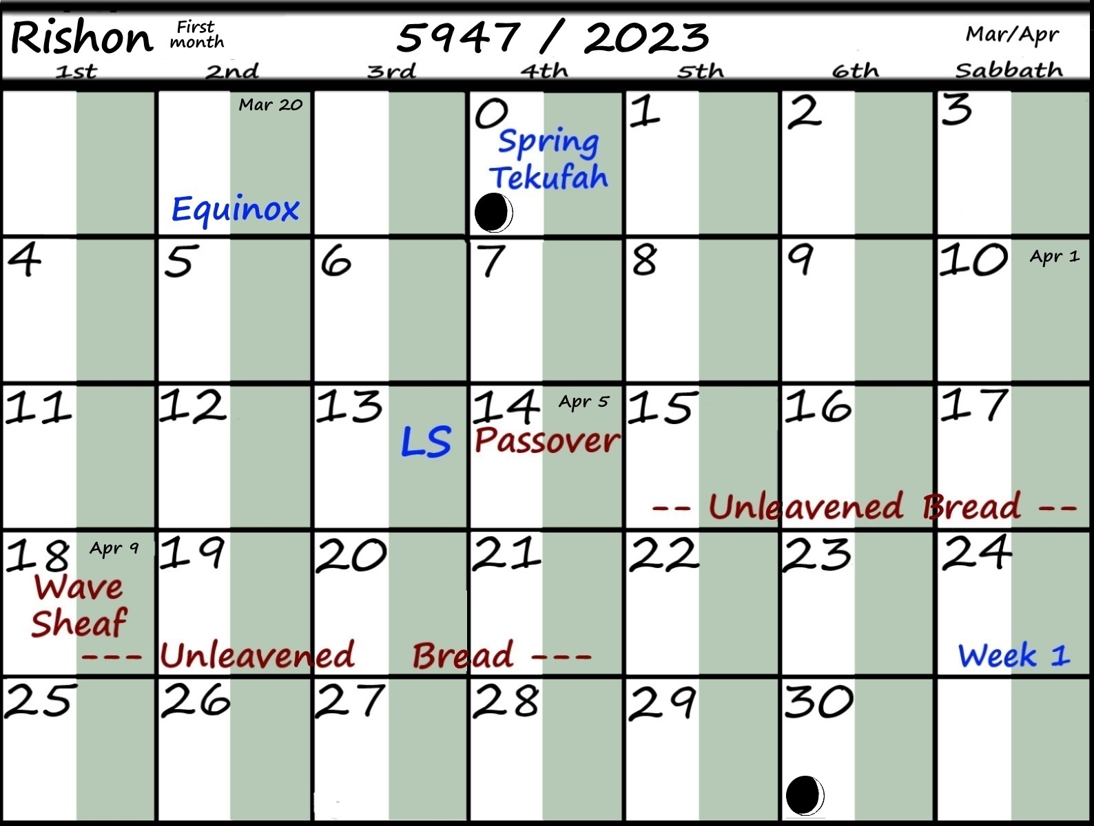

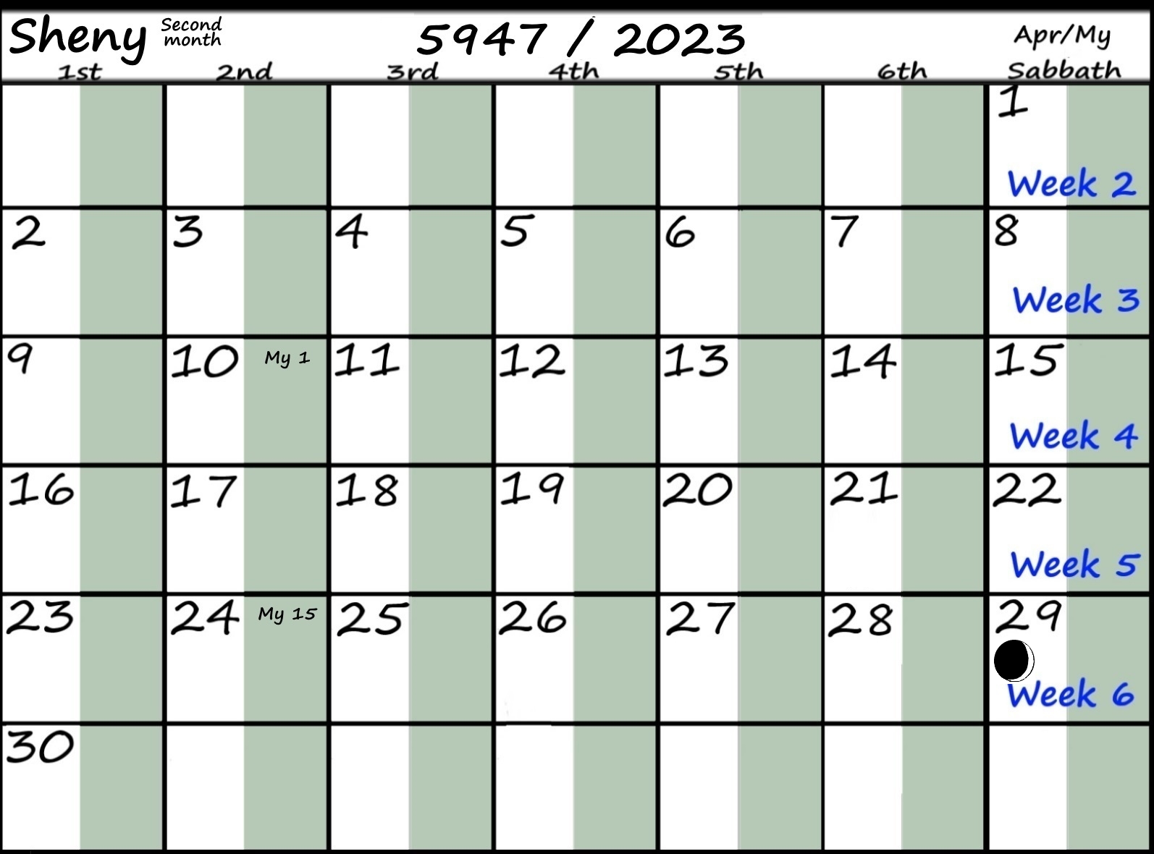
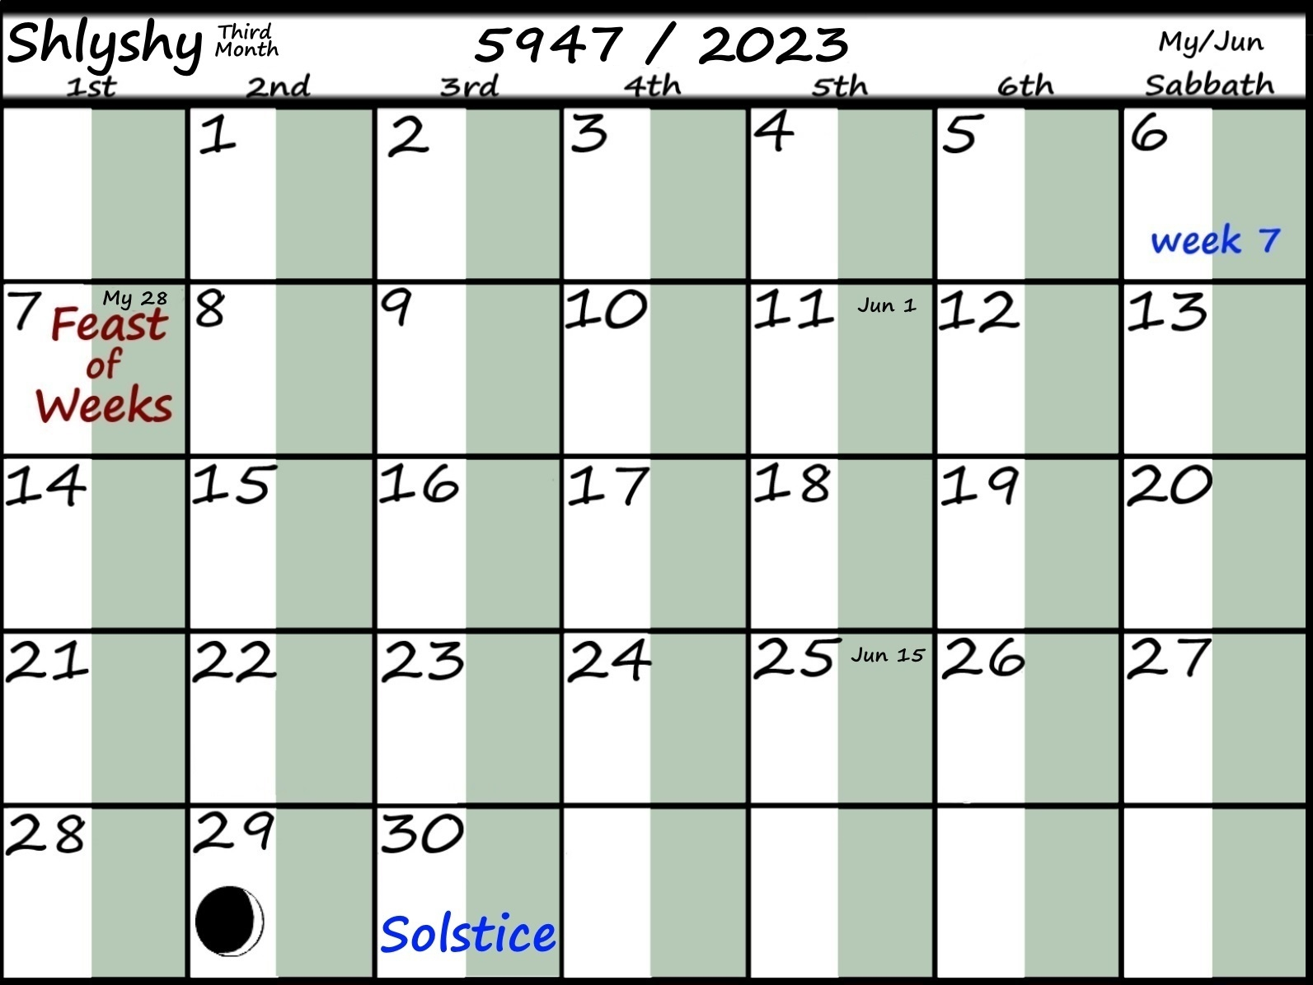

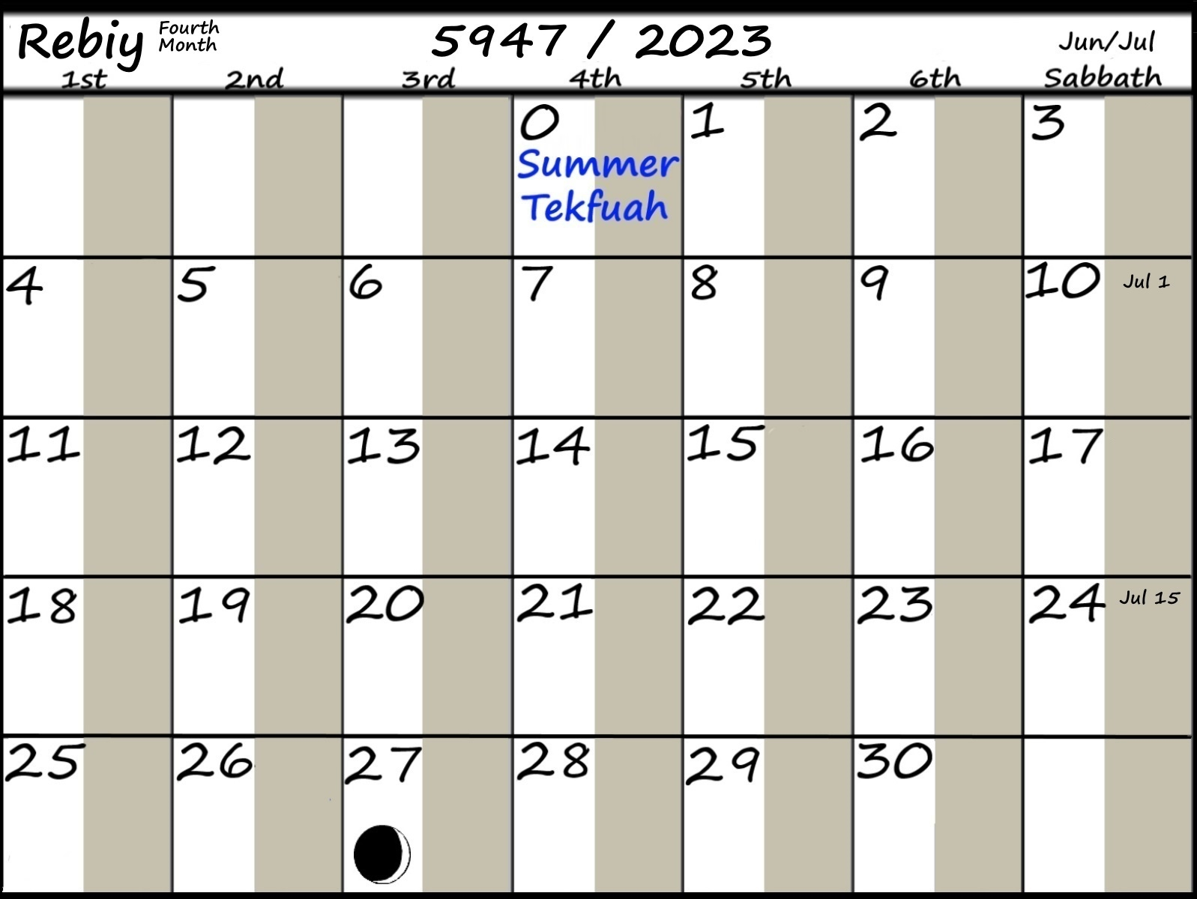
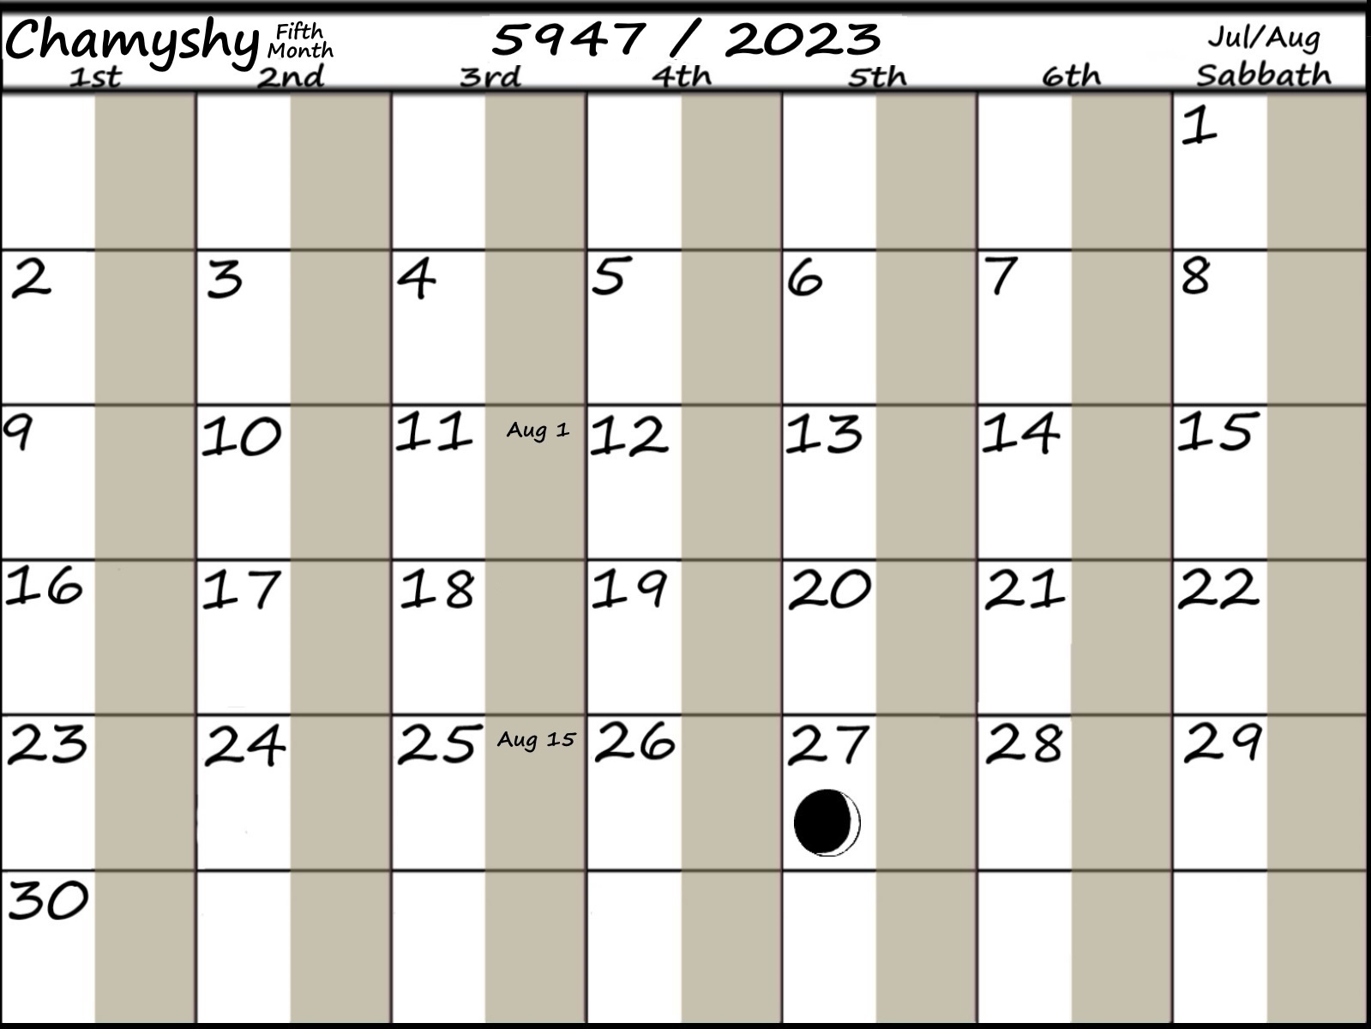

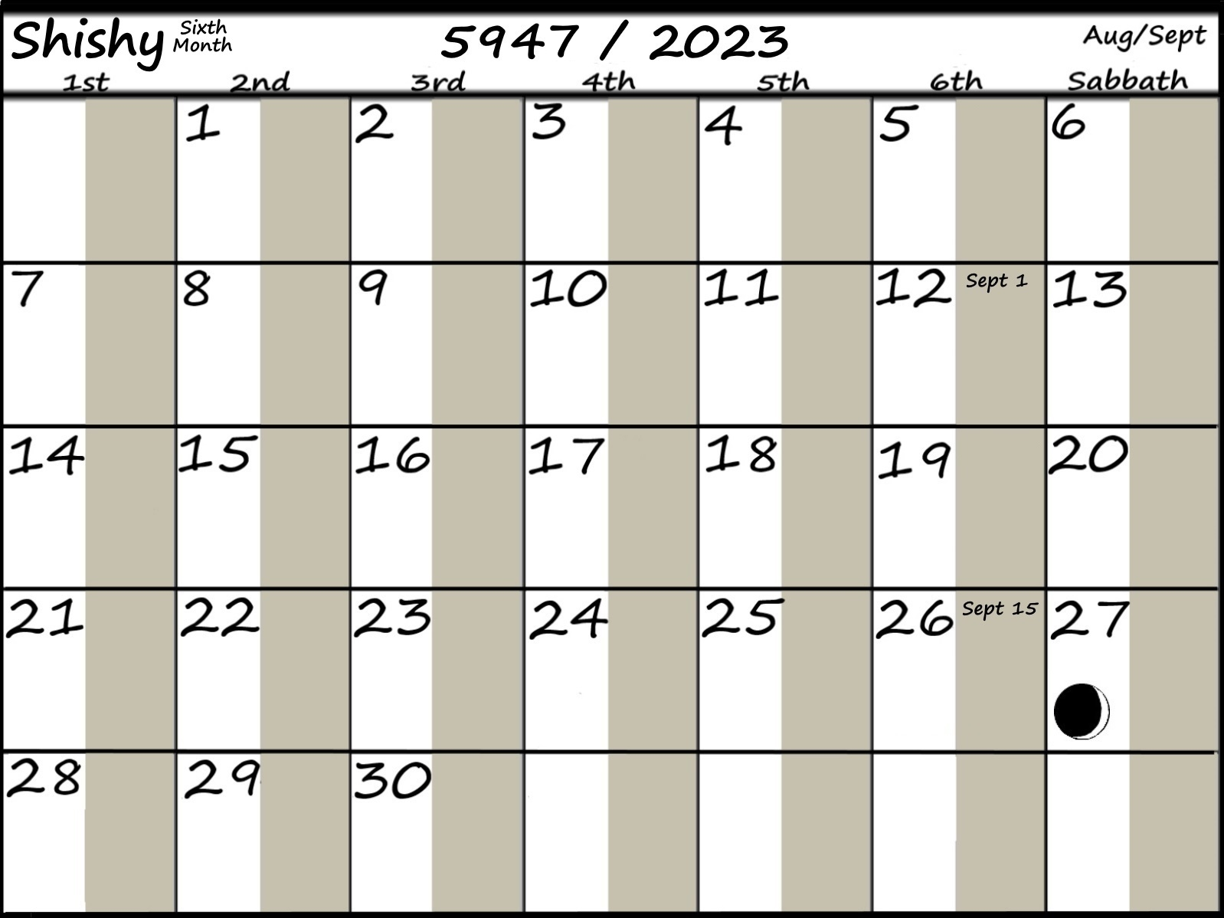
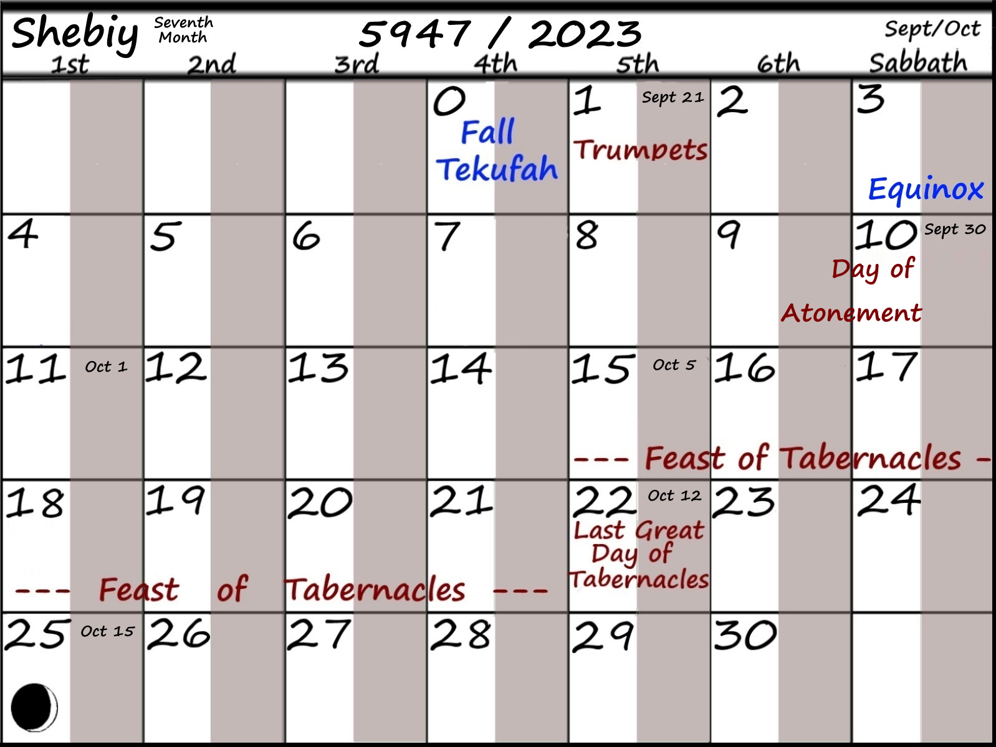

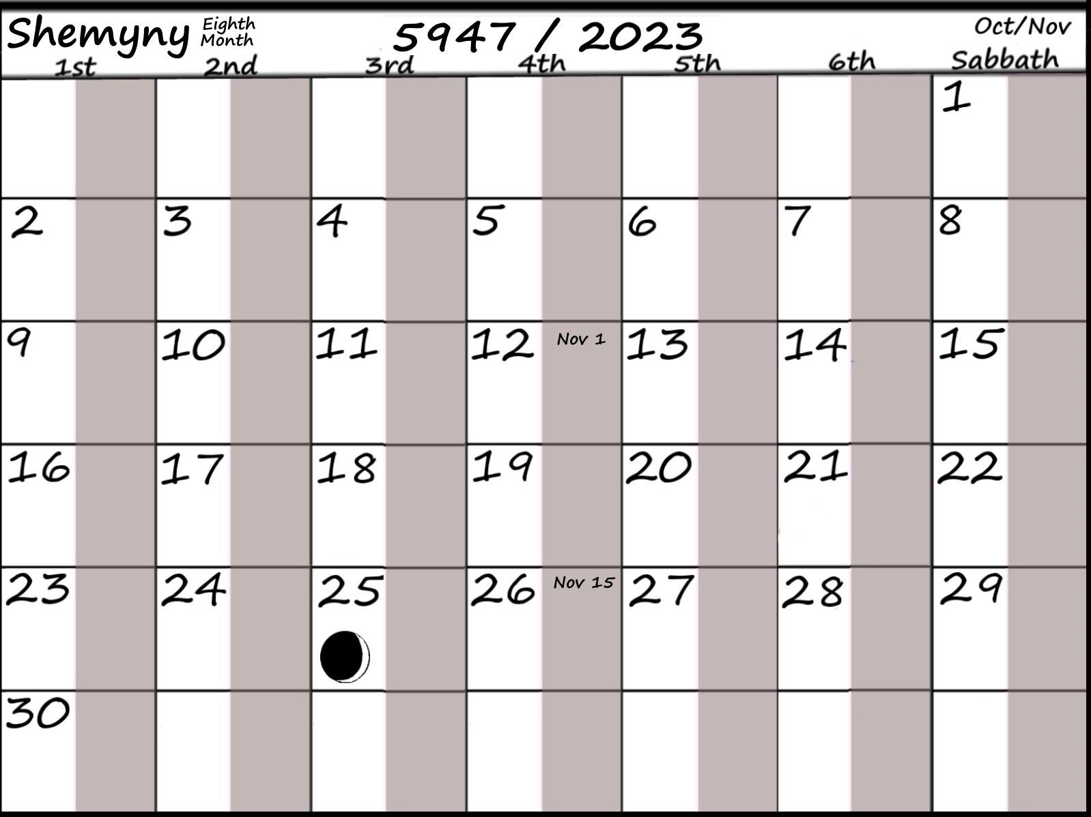
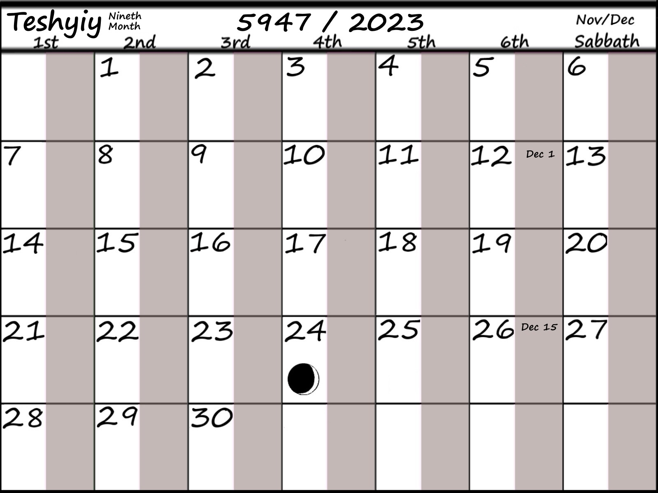

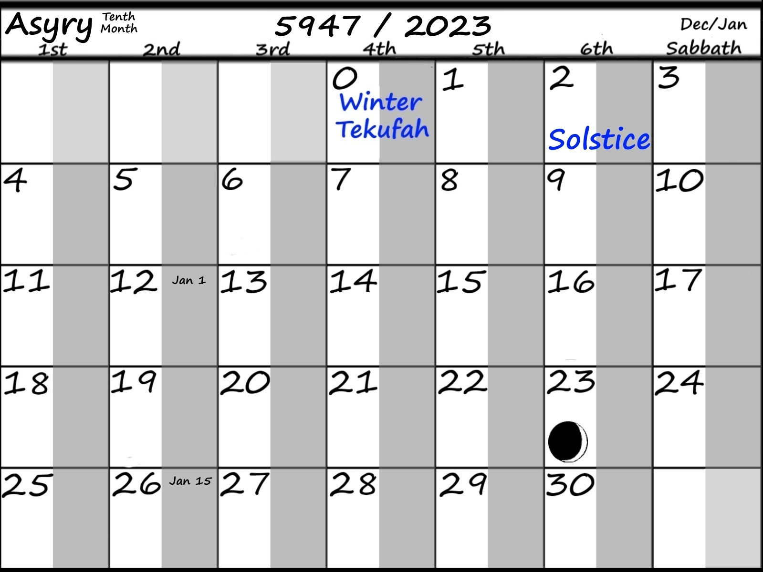
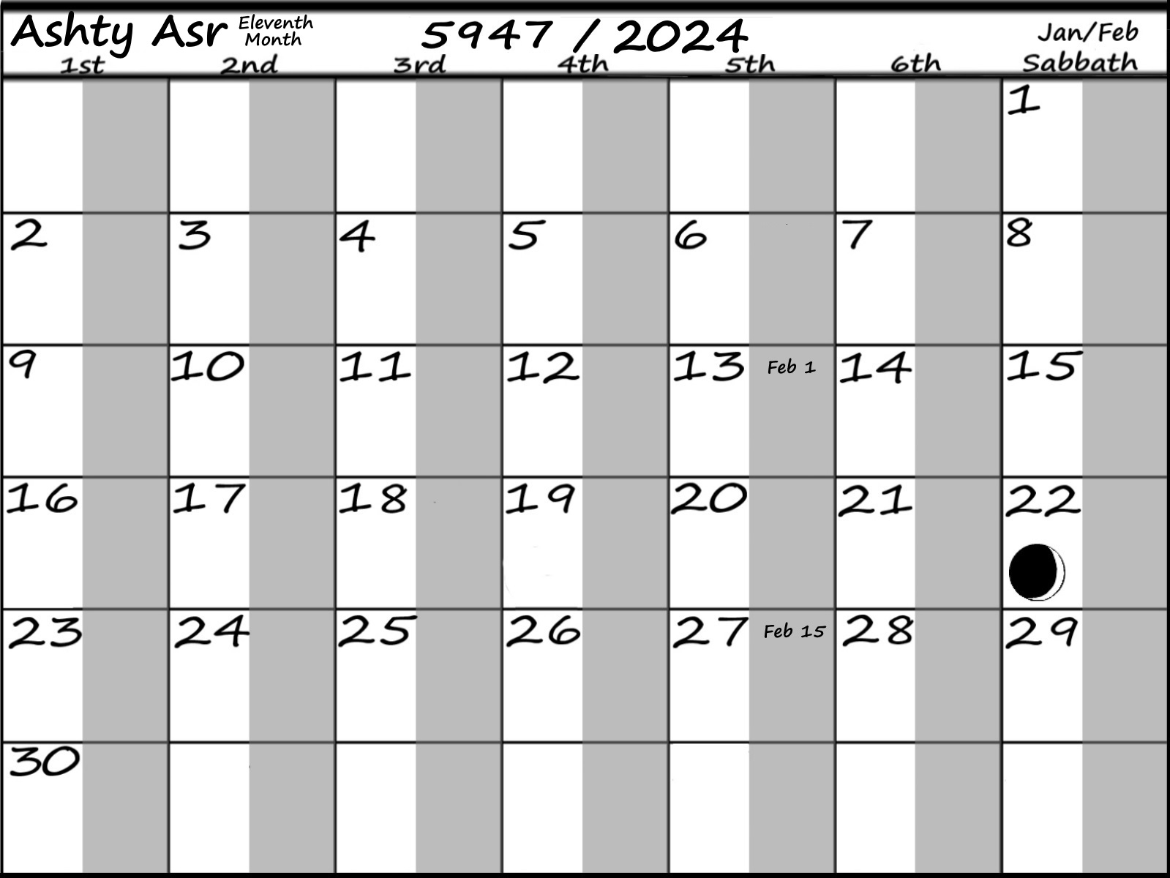

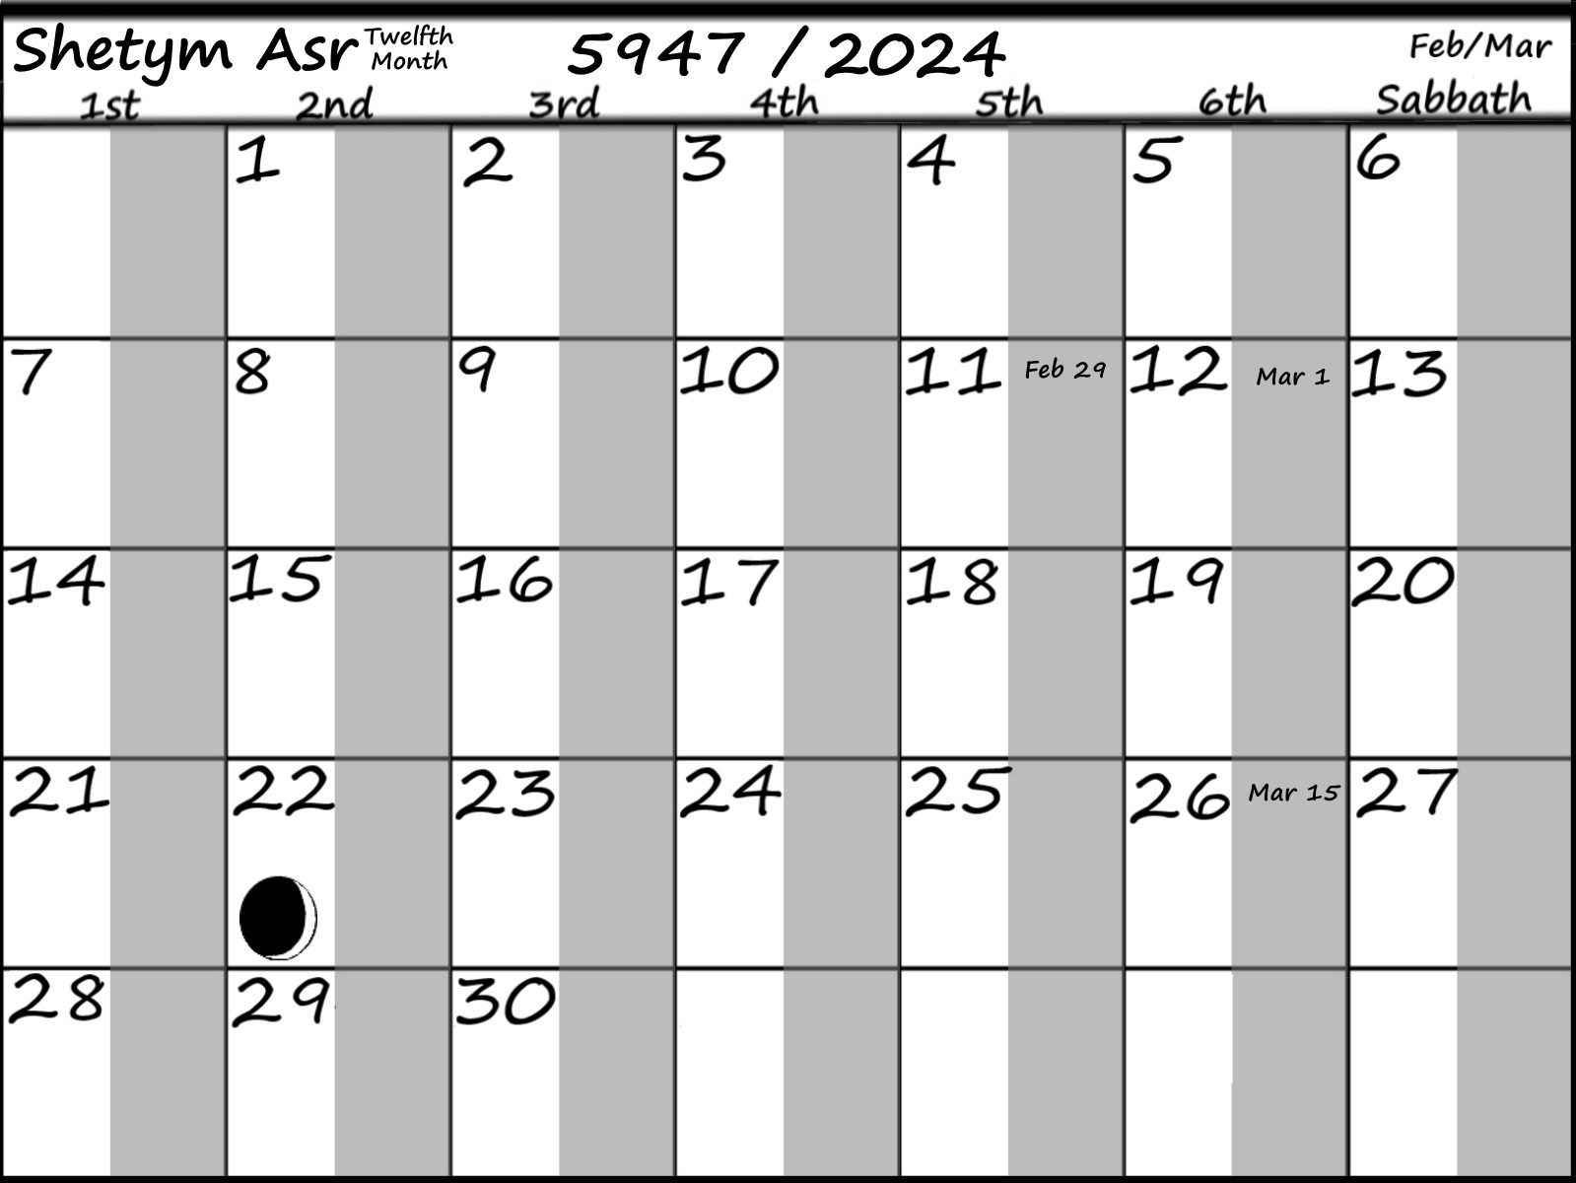
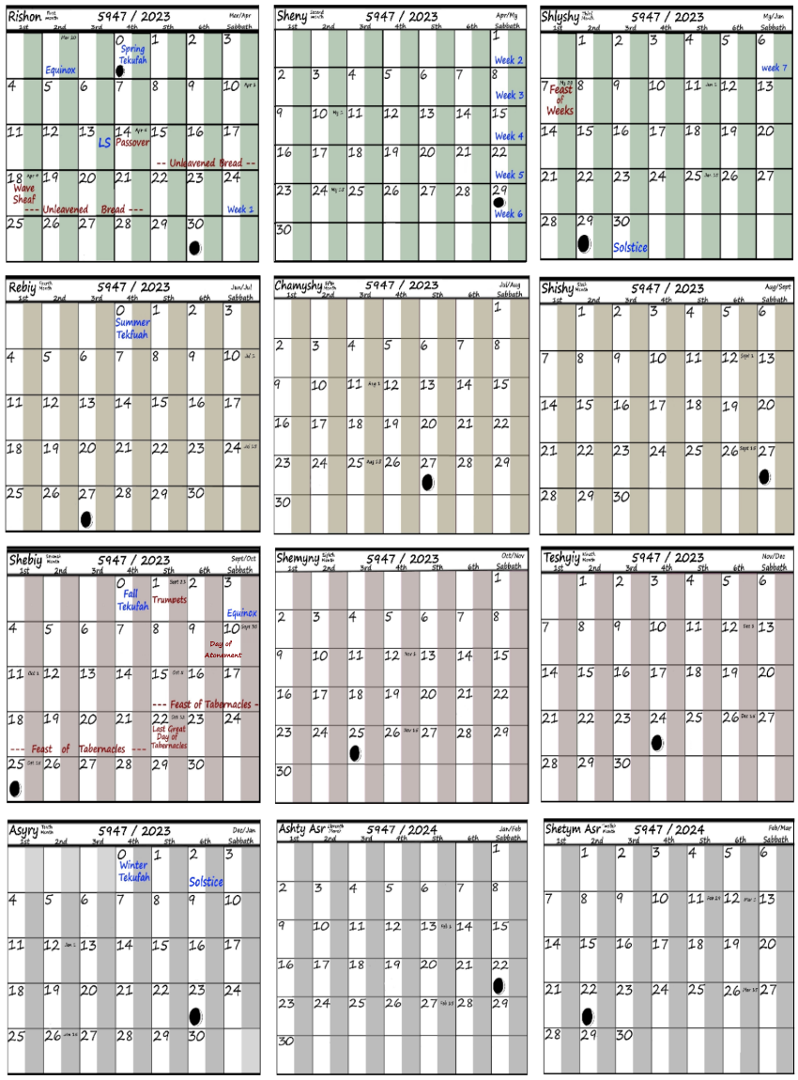

The 50 Years and 7 Sabbaths from the beginning to the 70th Yobel (Jubilee)
‘Gray colored of years are the Sabbaths of every seventh year.’
The 69th Yobel 5953/2029 then the 70th Yobel starting in 5954 and finishing in 6003
G.C. / A.D.
5954/2030 54 55 56 57 58 59 60s
5961/2037 61 62 63 64 65 66 67s
5968/2044 68 69 70 71 72 73 74s
5975/2051 75 76 77 78* 79 80 81s
5982/2058 82 83 84 85 86 87 88s
5989/2065 89 90 91 92 93 94 95s
5996/2072 96 97 98 99 6000 6001 6002s
6003/2079 70th Yobel
- Midst of the week
The Starting Seasons for the 70th Yobel (Jubilee)
Equinox of March 20th landing on a weekday beginning from Yobel 69th-2029 to 70^{tt}-2079
2034 --- 2045 --- 2051 --- 2056 --- 2062 --- 2073 --- 2079y Mon 1st
2029y--- 2035 --- 2040 --- 2046 --- 2057s --- 2063 --- 2068 --- 2074 Tue 2nd
2030 --- 2041 --- 2047 --- 2052 --- 2058 --- 2069 --- 2075 Wed 3rd
2031 --- 2036s --- 2042 --- 2053 --- 2059 --- 2064s --- 2070 Thru 4th
2037 --- 2043s --- 2048 --- 2054 --- 2065 ---2071s --- 2076 Fri 5th
2032 --- 2038 --- 2049 --- 2055 --- 2060 --- 2066 --- 2077 Sat 6th
2033 --- 2039 --- 2044 --- 2050s --- 2061 --- 2067 --- 2072 --- 2078s Sun 7th
The day of the Spring Equinox setting on different days of the week First to Seventh Each for a different year.

